**Lab 9 Name _________________________________________**

**MCSE 1 Network Printing**

**Objective:**

In this lab you will:

- install a networked printer

- install printer drivers

- configure a print server

- assign printer permissions

- configure printer pooling

- redirect jobs from a failed printer to another printer

**Procedure:**

**Sharing a local printer**

In this part of the lab we will pretend we have a small peer-to-peer network like you might have at home. If you have one printer, you can connect it directly to one computer with a USB cable and share it. You can then print to this shared printer from any computer in your home network.

___ Start Ottawa (Windows 7) and Hamilton (Windows 8). Log into the local Administrator’s account on each computer.

___ Make sure you can ping by name between Ottawa and Hamilton.

**Ottawa:**

___ On Ottawa, click on **Start** and **Devices and Printers**. On the top menu bar click on **Add a printer**.

___ At the first screen select **Add a local printer**.

___ On the **Choose a printer port** page, select the parallel port, **LPT1:(Printer Port)**.

With today’s printers, you would not be plugging a printer into a parallel port. You would more than likely use a USB connection. Most USB printers are installed with the installation disk that accompanies the printer. We want to install a local printer for which we do not have an installation disk so we will have to pretend it is a parallel port printer.

___ In the **Install the printer driver** select an **HP Laserjet 2300L PS** printer.

___ For the printer name, use your last name.

___ On the **Printer Sharing** page, share the printer using the default Share name which should be your last name.

___ Clear the check box **set as the default printer**

___ Finish installing the printer.

**1. Capture the window showing the new printer that bears your last name.**

___ Right-click on the new printer and set it as the default printer.

**2. How can you tell which printer is the default printer?**

Let’s install a printer on Hamilton that sends print jobs to the printer on Ottawa.

**Hamilton:**

In an earlier lab we configured the option to manage network passwords using

the credentials of Eng1 on Ottawa. Let’s remove those credentials.

___ Log into Hamilton as the **Lab8** user.

___ Open the control panel. Select **User Accounts**, then **Manage Windows Credentials**. Click on **Remove**. See figure 1 on the next page.

___ Close all the windows.

Let’s add the printer to Hamilton.

___ Log into Hamilton as the Administrator of Hamilton.

___ Open the control panel. Click on **View devices and Printers**.

___ In the menu bar at the top of the window, click on **Add a printer**.

___ Click on **The printer that I want isn’t listed**. See figure 2

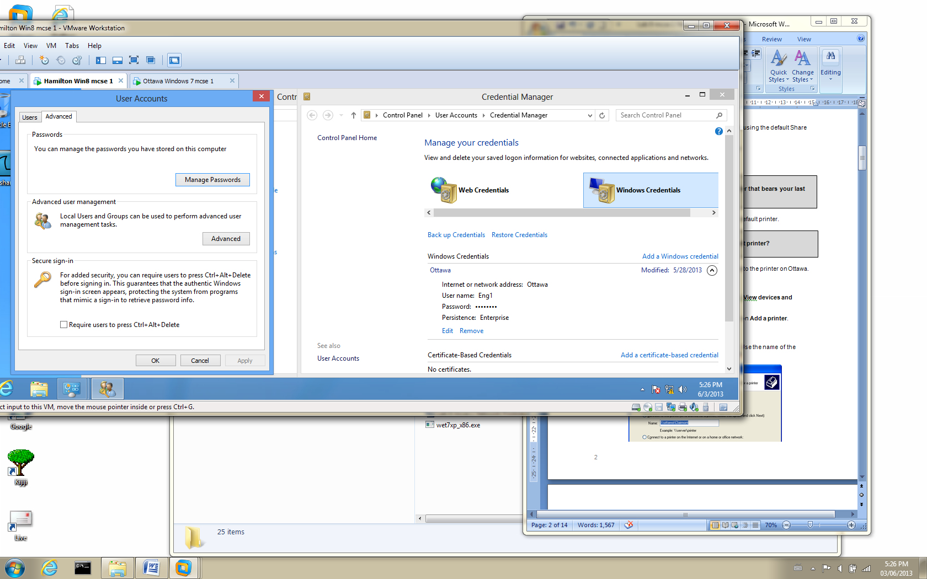

Fig. 1 Click on Remove to get rid of the Eng1 credentials

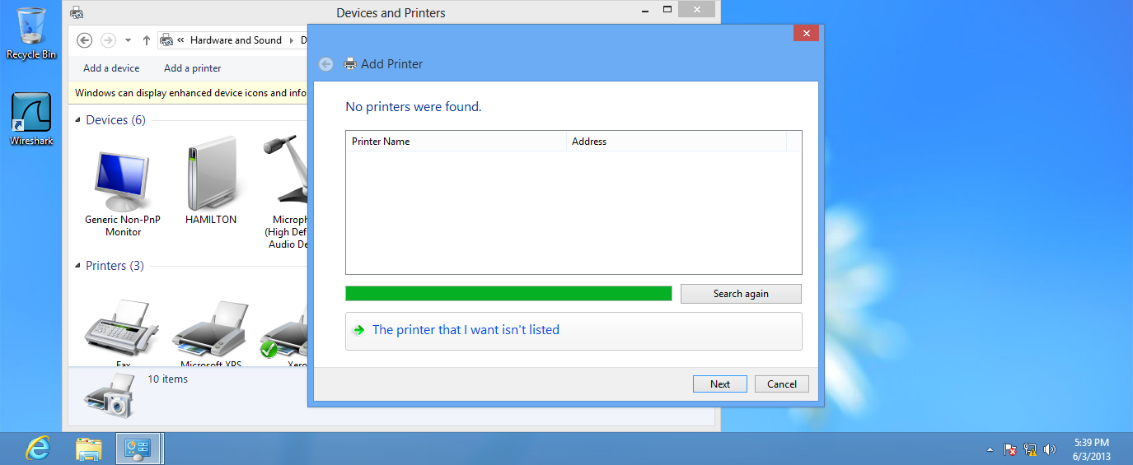

Fig. 2 Click on **The printer that I want isn’t listed**

___ Configure the next page as shown in figure 3. Use the name of the shared printer on Ottawa in place of **Clairmont**

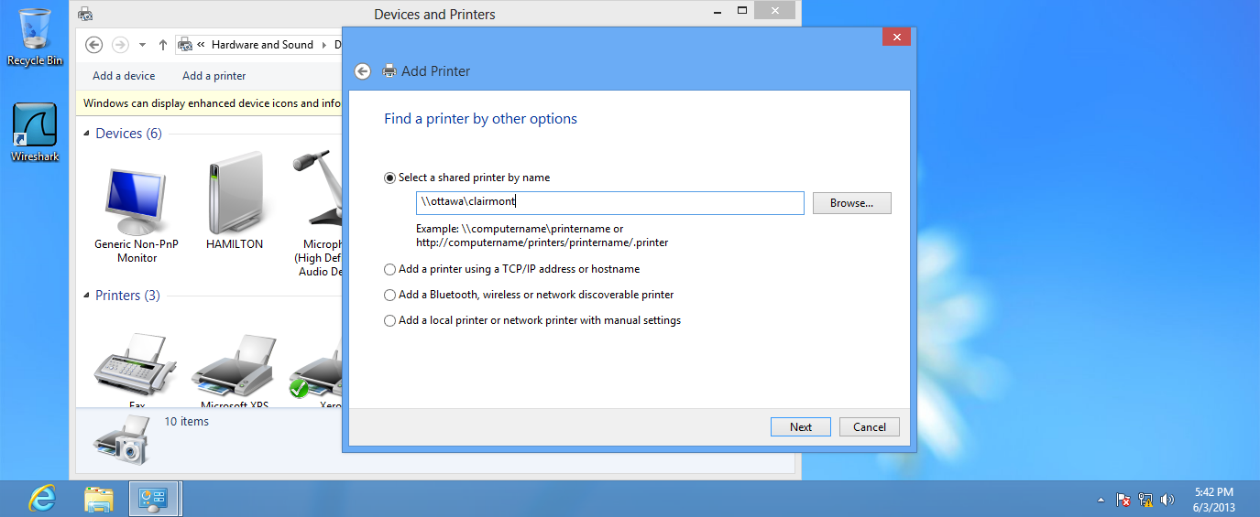

Fig. 3 Pointing the new printer on Hamilton to the printer on Ottawa

___ Click on **Next**. It will take a few minutes while it goes and finds the drivers on Ottawa to load onto Hamilton.

___ On the next page, make sure the box opposite **Set as the default printer** is checked. Click on **Finish**.

**3. Capture the window showing the new printer pointing to Ottawa.**

___ Right-click on the printer on Hamilton. Click on **Printer Properties**. Click on the **Print test page** button on the **General** page of the printer.

___ Open the printer queue on Hamilton by double-clicking on the printer and then clicking on **See what’s printing**.

**4. Capture the printer queue on Hamilton showing the print job waiting to be printed. Make sure all the columns are expanded so you can read what’s in each column.**

**5. Capture the printer queue on Ottawa showing the print job waiting**

**to be printed.**

**6. On Ottawa, open the print queue folder (c:\windows\system32\spool\printer). Capture the view in the Explorer showing the two files that make up the print job.**

___ Open the print queue folder on Hamilton. Notice there are no files in the print queue folder. They were sent to the print server, Ottawa.

**Hamilton:**

___ Log out on Hamilton and log back in as the **Lab 8** user.

___ Check the **Printers and Faxes** folder.

**7. Is the network printer the Administrator installed Hamilton, available for the Lab 8 user?**

**Ottawa:**

___ Log out of Ottawa and log back in as arch1.

___ Open the **Devices and Printers** folder.

**8. Is the local printer the Administrator installed Ottawa, available for the arch1 user?**

**9. What can you deduce from the answers in #7 and #8?**

It is possible to control who has access to the shared printer by changing the

DACL of the printer. Let’s try it.

___ Log into Ottawa as the Administrator.

___ Open the **Printer Properties** pages of the printer you created.

___ click on the **Security** tab.

___ Remove the group **Everyone**.

**Hamilton:**

___ Make sure you are still logged in as the **Lab8** user.

___ Open the **Devices and Printers** folder on Hamilton.

___ Try adding the printer on Ottawa, to Hamilton.

Notice access to the printer on Ottawa is “**Denied**” now that the group **Everyone**

has been removed from the local printer on Ottawa.

**10. Capture the Printers and Faxes folder on Hamilton showing the message that says “Windows cannot connect to the printer”**

___ Log in as the Administrator.

___ Remove the printer from Hamilton.

**Ottawa:**

___ Log in as the Administrator.

___ Remove the printer from Ottawa.

**Networked Printers**

It is becoming more common to find printers containing NICs. This allows them to be connected to the Ethernet so any computer can be configured to send print jobs to them. Networked printers add great flexibility to print services. You are no longer restricted to placing the printer within reach of a USB cable or parallel cable since the printer does not have to be directly connected to a computer.

There are two ways to configure network printing employing a networked printer:

1. each computer can print directly to the printer

2. use a printer server that prints to the printer and all other computers send

print jobs to the print server.

Since using a print server affords the greatest number of advantages, we will configure our network to use a print server. Ottawa will be the print server as it was in the first part of this lab. Hamilton will send print jobs to it.

___ Make sure you are logged in as the Administrator of Hamilton and Ottawa.

Let’s assume we have configured an IP address of 10.1.1.55/24 on our networked printer.

**Ottawa:**

___ Click on **Start** and select **Devices and Printers** and add a new printer.

___ Configure the printer as shown in the following screen captures.

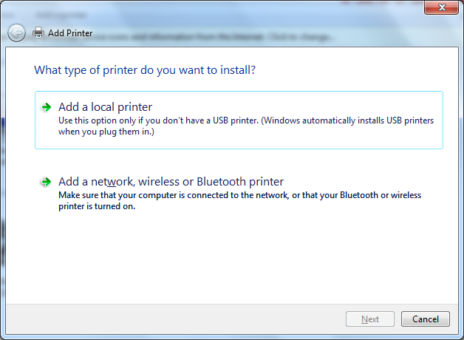

Select this option

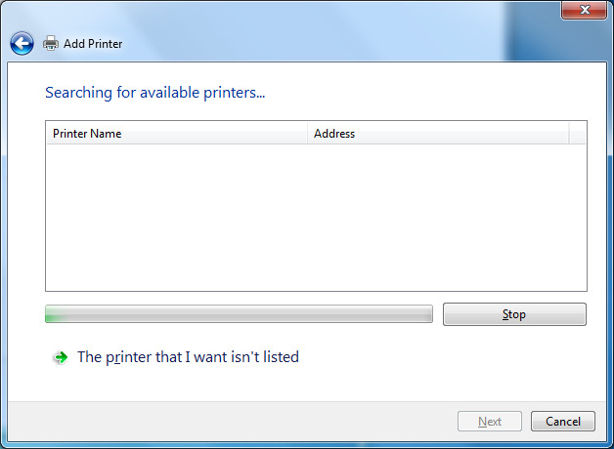

Select this option

Fig. 4 Configuring a networked printer on a Windows 7 computer

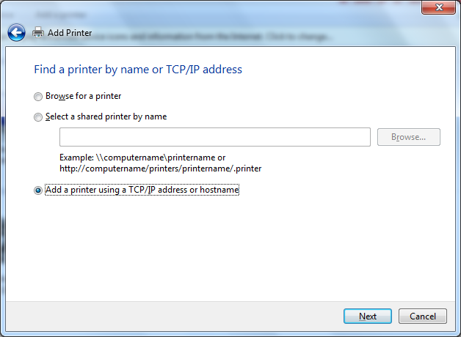

Select this option

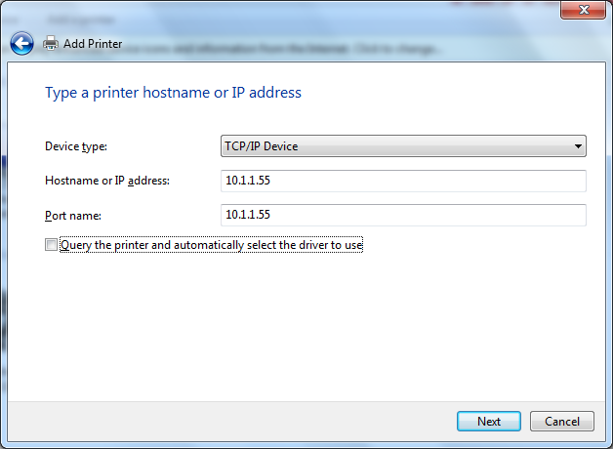

Normally, you would leave this box checked but we don’t actually have a printer at 10.1.1.55 so we must clear it.

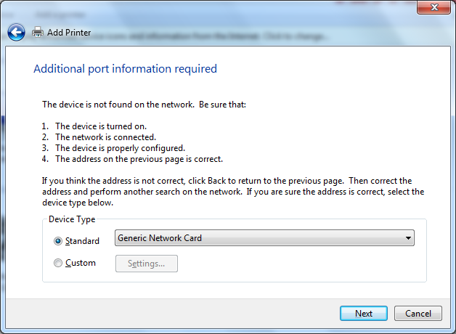

Select this option

Fig. 5 Configuring a networked printer on a Windows 7 computer

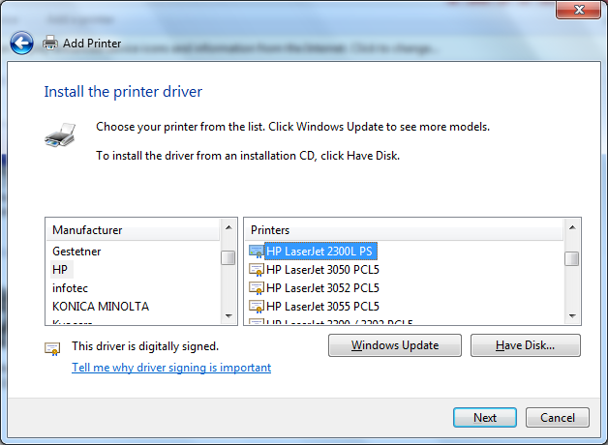

Select this printer

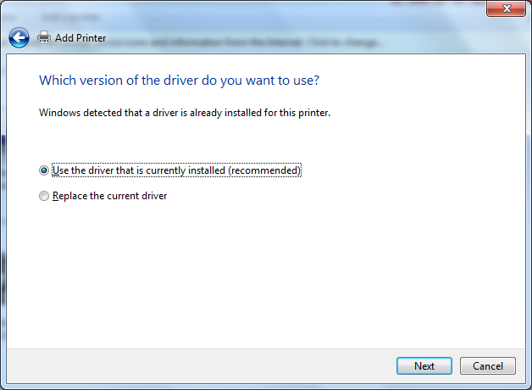

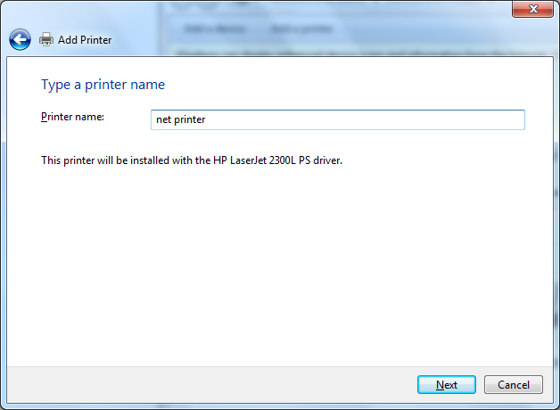

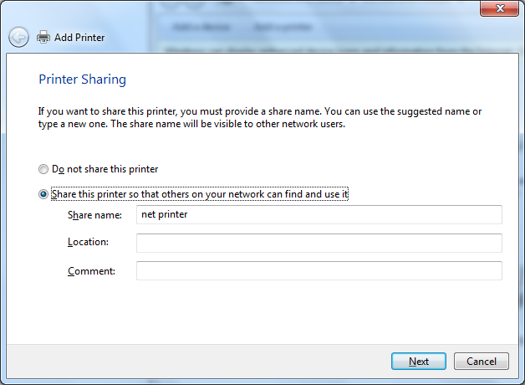

Fig. 6 Configuring a networked printer on a Windows 7 computer

___ Set the printer as the default printer.

___ Don’t print a test page.

**Hamilton:**

___ Add a network printer the way you did in the first part of the lab. This time point the printer to the **net printer** on Ottawa.

**11. Capture the Printers and Faxes folder on Hamilton showing the printer is pointing to the “net printer on Ottawa”.**

___ Print a test page on Hamilton.

**12. Capture the print queue in the printer on Ottawa.**

**Printer Pooling**

Printer pooling allows one installed printer to point to a number of actual printers.

The purpose is to speed up printing in an environment where there is a lot of

printing by multiple users, such as a computer lab at a college or university.

**Ottawa:**

___ Add another network printer on IP address 10.1.1.56.

___ Make sure you select the same printer; HP Laserjet 2300 ps.

___ The printer name will be **net printer 2**.

___ Set the printer as default.

___ Don’t bother printing a test page.

**13. Capture the Devices and Printers folder showing the 2 printers.**

Let’s configure printer pooling.

___ Open the **printer properties** page of **net printer**. Click on the **Ports** tab.

___ Click on **Enable printer pooling**.

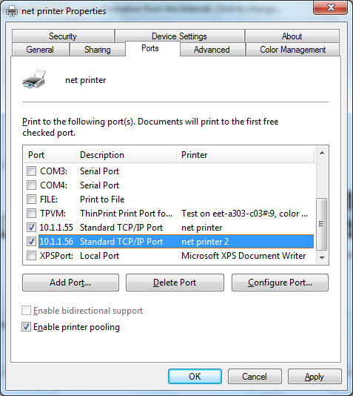

Fig. 9 Adding a second port for printer pooling

___ Click on the second printer 10.1.1.56.

Now when the user sends a print job to the **net printer**, if the printer is busy the

job will be sent to the **net printer 2** printer.

**14. Capture the Ports page of printer1 showing that printer pooling has been configured.**

**Redirecting print jobs on a failed printer**

**Ottawa:**

___ Deactivate the printer pooling option on the **net** **printer**.

A printer might fail while people are still sending print jobs to it. The print jobs will

build up in the queue. The Administrator can configure a printer to send print

jobs from a failed printer to another printer that is still working.

Let’s assume **net printer** has malfunctioned and will not print anymore. We want

to redirect any print jobs sent to **net printer** to **net printer 2**.

___ Open the properties page of **net printer**. Click on the **Ports** tab. Click on **Add Port**.

___ Highlight **Local Port** and click on the **New Port** button.

___ For the Port Name use **\\Ottawa\net** **printer2**.

**15. Capture the Ports page of printer1 showing that print jobs are now being redirected to printer2.**

**Hamilton:**

___ Print two test pages from **net printer**.

___ Open the printer queue on printer2. You should see two “down-level” documents waiting to be printed.

**16. Capture the printer queue on net printer 2 showing the**

**“Remote downlevel Documents” waiting to be printed.**

[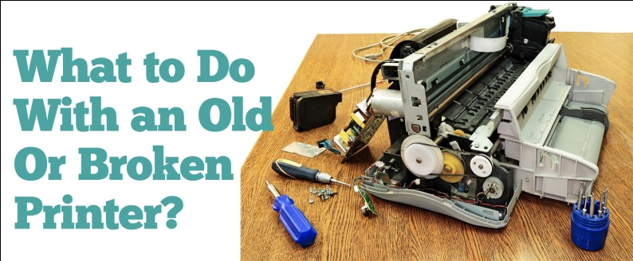](http://www.google.ca/url?sa=i&rct=j&q=&esrc=s&frm=1&source=images&cd=&cad=rja&docid=UwYN4f3vkW4zZM&tbnid=GLJj6-Gy7KR3TM:&ved=0CAUQjRw&url=http://www.inkpal.com/ink-news/what-to-do-with-your-old-or-broken-printer/&ei=kj-tUbinDcTuyAHCiYGYBA&bvm=bv.47244034,d.aWc&psig=AFQjCNGYqZuCsCoSP9rDb5Mmk6OZFbAVeQ&ust=1370394778896772)

*Give up and go home !*